1.
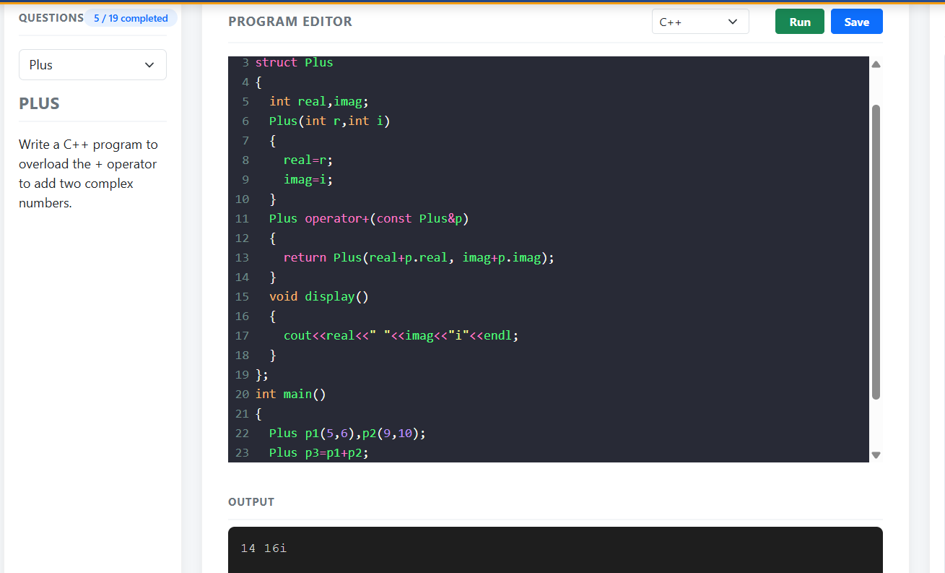

#include <iostream>
using namespace std;
struct Complex
{
int real, imag;
Complex(int r, int i)
{
real = r;
imag = i;
}
Complex operator+(const Complex &c)
{
return Complex(real + c.real, imag + c.imag);
}

void display()
{
cout << real << " + " << imag << "i" << endl;
}
};
int main()
{
Complex c1(2, 3), c2(4, 5);
Complex c3 = c1 + c2;
c3.display();
return 0;
}

2.
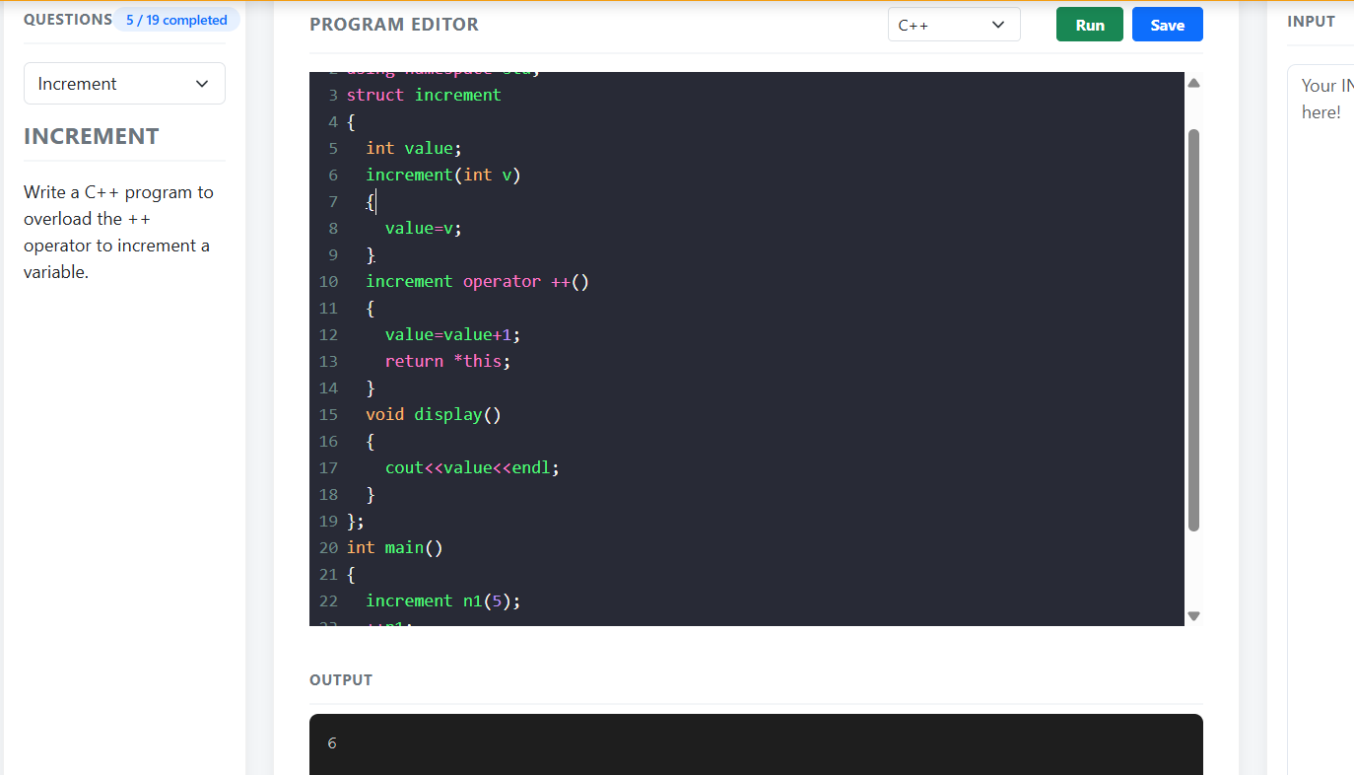

#include <iostream>
using namespace std;
struct Increment
{
int value;
Increment(int v)
{
value = v;
}
Increment operator++()
{
value = value + 1;
return *this;
}
void display()
{
cout << value << endl;
}
};
int main()
{
Increment n1(5);
++n1;
n1.display();
return 0;
}

3.
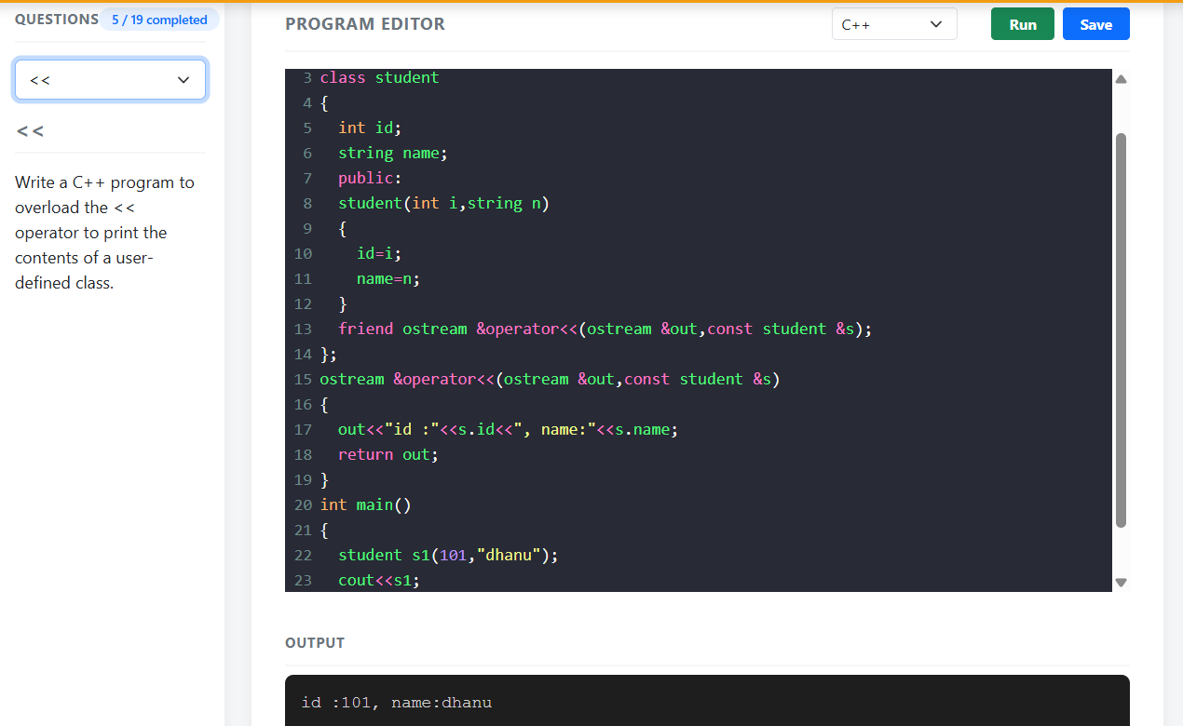

#include <iostream>
using namespace std;
class Student
{
int id;
string name;
public:
Student(int i, string n)
{
id = i;
name = n;
}
friend ostream &operator<<(ostream &out, const Student &s);
};
ostream &operator<<(ostream &out, const Student &s)
{
out << "ID: " << s.id << ", Name: " << s.name;
return out;
}
int main()
{
Student s1(101, "sonu");
cout << s1;
return 0;
}

4.
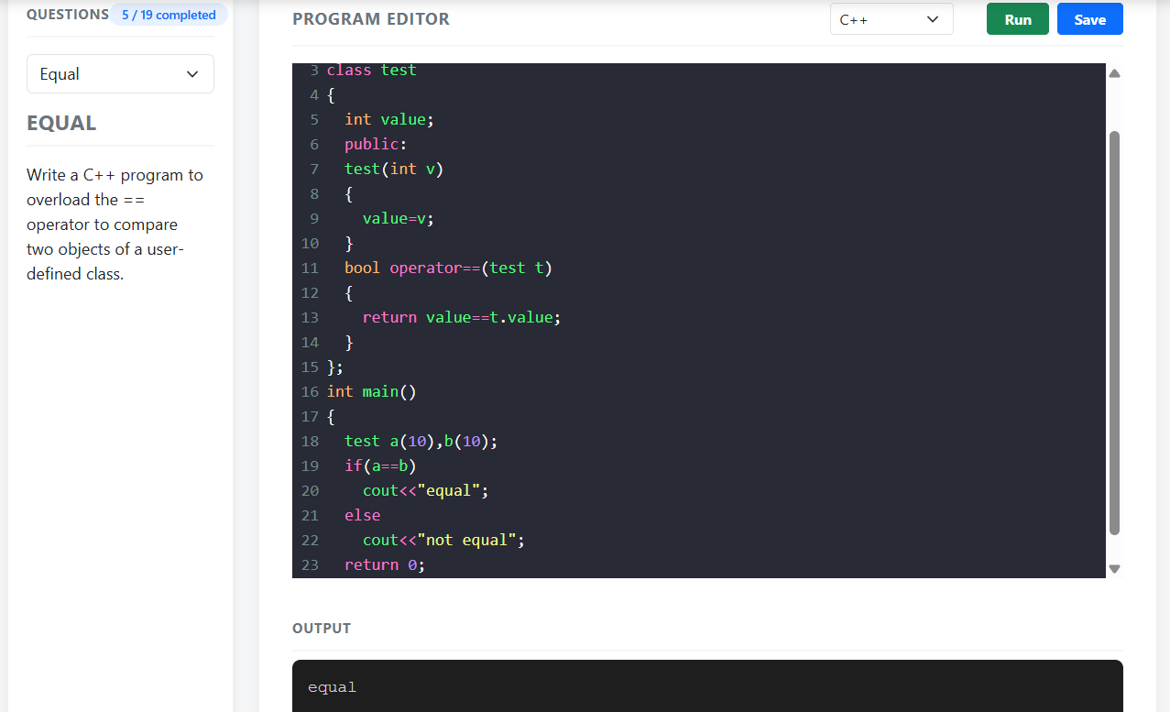

#include <iostream>
using namespace std;
class Test
{
int value;
public:
Test(int v)
{
value = v;
}
bool operator==(Test t)
{
return value == t.value;
}
};

int main()
{
Test a(10), b(10);
if (a == b)
cout << "Equal";
else
cout << "Not Equal";

return 0;
}

5.
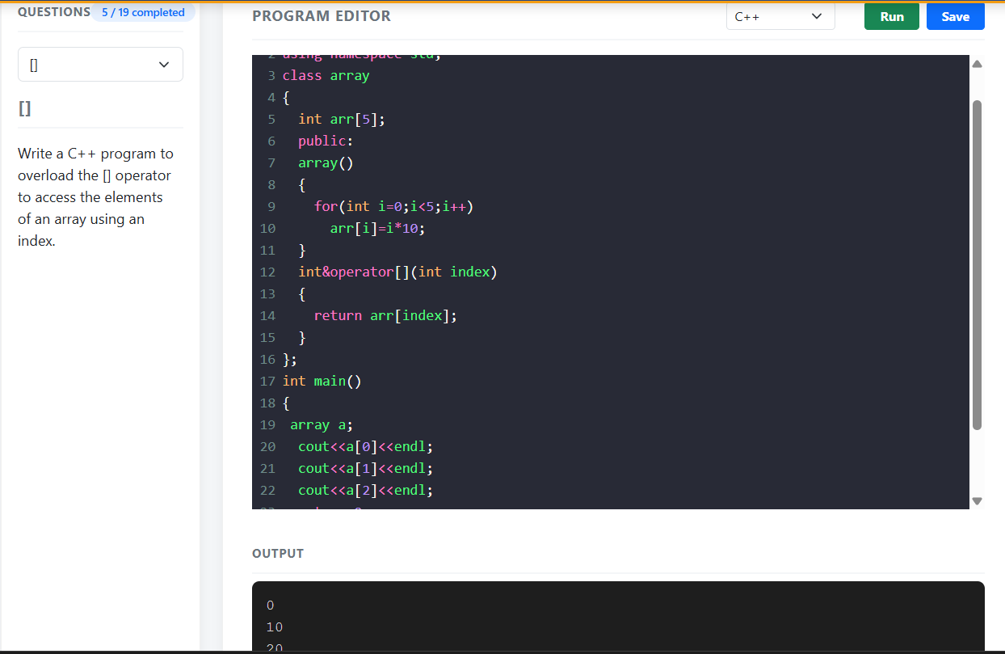

#include <iostream>
using namespace std;
class Array
{
int arr[5];

public:
Array()
{
for (int i = 0; i < 5; i++)
arr[i] = i * 10;
}
int& operator[](int index)
{
return arr[index];
}
};

int main()
{
Array a;

cout << a[0] << endl;
cout << a[1] << endl;
cout << a[2] << endl;

return 0;
}

